FINAL TERM PROJECT REPORT

Made By Rohaan Nadeem

PROJECT NAME
Title:- Hospital Management System

Objectives:-
- Checking Doctors Available time.
- Appointment process with doctors.
- Adding staff information.
- Checking staff record.
- Password change process.
- File handling

Introduction:-
Our project was to make a Hospital Management System. Both of us enjoyed it. This project plays a very good affect on us. By doing this we got many information. Our thinking practice is done in this period. This work will definitely help us allot, because it the common thing in our society means to say that its scope is very high in out society, Hospital is common in this society so we get allot of information and solution and ideas by doing this project. By doing this we discover many new things for us.

Problem Statement:-

We face a problem that we also done the file handling of Appointment record but it don’t work accurately so we kicked that portion from our project.

Results:-

Entering password which we stored in password.txt file :-
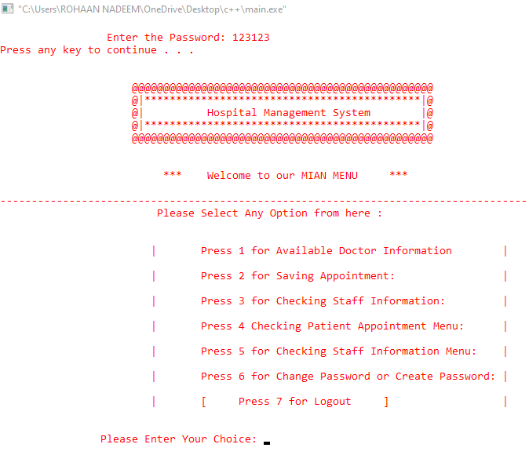
Checking the Doctors information of availablity in no.1 :-
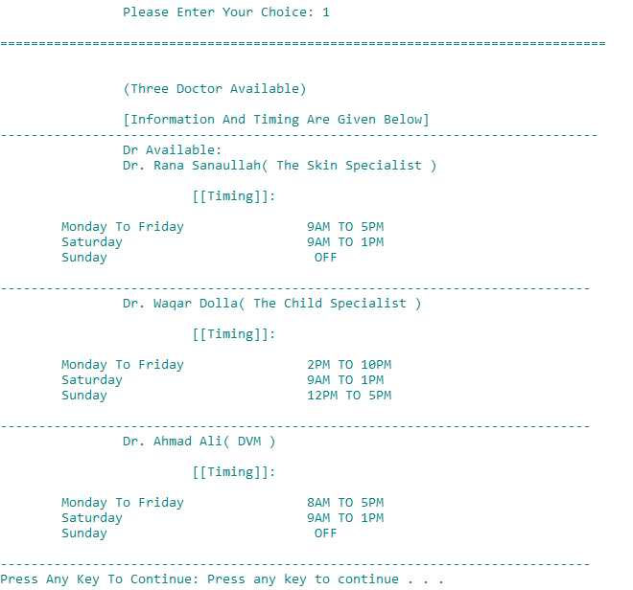

Entering the appointment information in no.2 :-

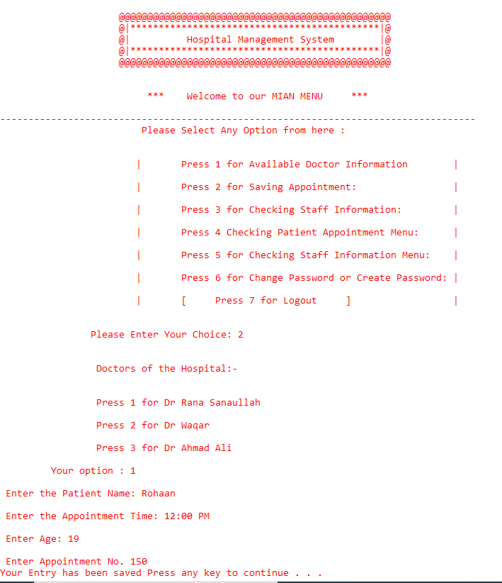

Entering staff information in the no.3 :-

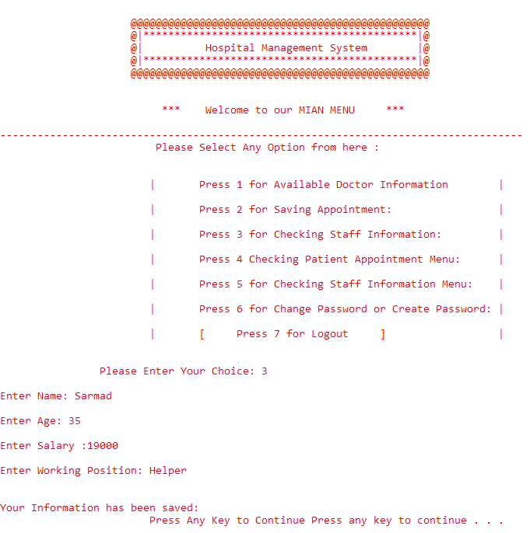

Checking the Appointment information of Doctors :-

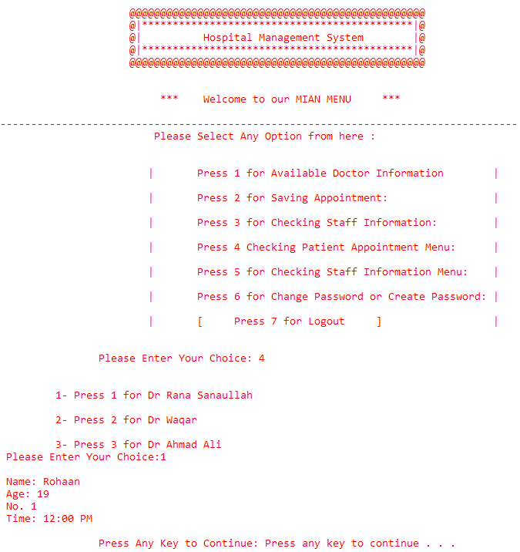

Checking the Staff information in no.5 :-
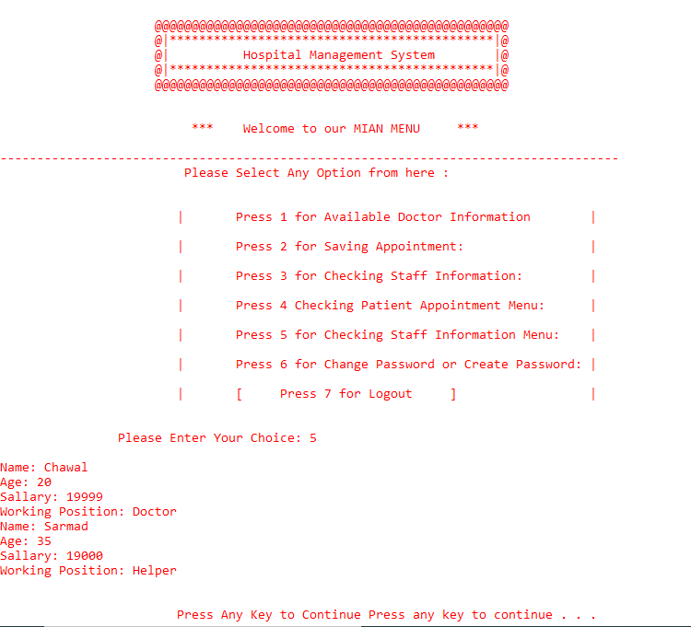

With the help of file handling Staff data has been saved in the staff.txt

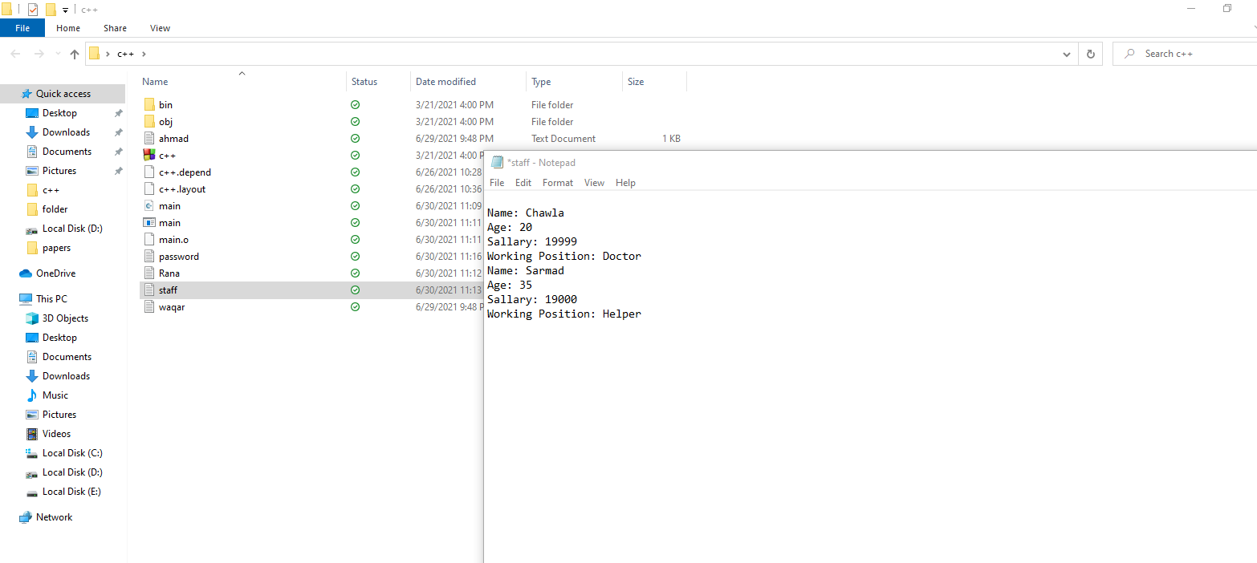
Changing the password and storing in the password.txt file :-
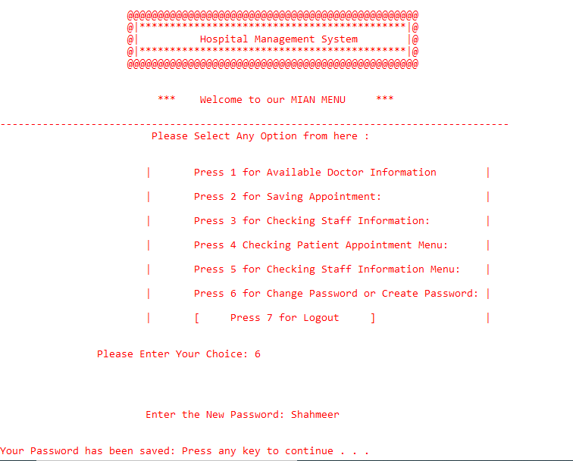

With the help of file handling new password has been saved in the password.txt

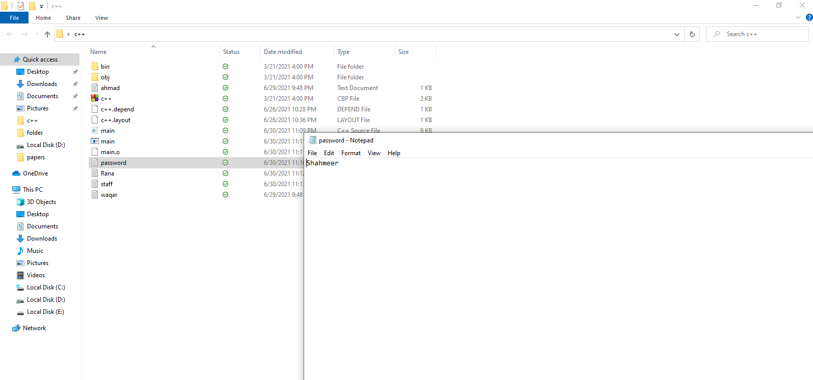

Code:-
Paste complete code of your project here.
#include <iostream>
#include <conio.h>
#include <fstream>
#include <cstring>

using namespace std;

void menu();
void pascode();
void cpascode();

//////////////////////Class One////////////////////

class one
{
public:
virtual void get() = 0;
virtual void show() = 0;
};

//////////////////Class info//////////////////

class info : public one
{
public:
char name[50], time[50];
int num, age;
void get()
{
cout << "\n Enter the Patient Name: ";
cin >> name;
cout << "\n Enter the Appointment Time: ";
cin.ignore();
cin.getline(time, 50);
cout << "\n Enter Age: ";
cin >> age;
cout << "\n Enter Appointment No. ";
cin >> num;
}
void show()
{
cout << "\n Name: " << name;
cout << "\n Age: " << age;
cout << "\n No. " << num;
cout << "\n Time: " << time;
}
};

///////////////////////////////class rana////////////////////////////

class rana : public info
{
public:
info a1;
void get()
{
ofstream out("Rana.txt", ios::app | ios::binary);
a1.get();
out.write((char*)&a1, sizeof(info));
out.close();
cout << "Your Entry has been saved ";
system("pause");
menu();

}
void show()
{
ifstream in("rana.txt");
if (!in == NULL)
{
in.read((char*)&a1, sizeof(a1));
a1.show();

cout << "\n\n\t\tPress Any Key to Continue: ";
system("pause");
menu();
}
else {
while (!in.eof())
{
cout << "\n\nNo Data in the file ";
}
in.close();
system("pause");
menu();
}

}
};

////////////////////////////Class Waqar///////////////////////
class waqar :public info
{
public:
info a1;
void get()
{

ofstream out("waqar.txt");
a1.get();
out.write((char*)&a1, sizeof(info));
out.close();
cout << "Your Entry has been saved ";
system("pause");
menu();

}
void show()
{
ifstream in("waqar.txt", ios::app | ios::binary);
if (!in == NULL)
{
in.read((char*)&a1, sizeof(a1));
a1.show();

cout << "\n\n\t\tPress Any Key to Continue: ";
system("pause");
menu();
}
else {
while (!in.eof())
{
cout << "No Data in File";

}
in.close();
cout << "Press Enter to Continue ";
system("pause");
menu();
}

}
};

/////////////////////////////Ahmad class///////////////////////////
class ahmad : public info
{
public:
info a1;
void get()
{
ofstream out("ahmad.txt", ios::app | ios::binary);
a1.get();
out.write((char*)&a1, sizeof(info));
out.close();
cout << "Your Entry has been saved ";
system("pause");
menu();

}

void show()
{
ifstream in("ahmad.txt", ios::app | ios::binary);
if (!in == NULL)
{
in.read((char*)&a1, sizeof(a1));
a1.show();

cout << "\n\n\t\tPress Any Key to Continue: ";
system("pause");
menu();
}
else {
while (!in.eof())
{
cout << "No Data in File";

}
in.close();
cout << "Press Enter to Continue ";
system("pause");
menu();
}

}
};

////////////////////////staff class//////////////////////////

class staff :public one
{
public:

char all[999];
char name[50], age[20], sal[30], pos[20];

void get()
{
ofstream out("staff.txt", ios::app);
{
cin.sync();
cout << "\nEnter Name: ";
cin >> name;
cout << "\nEnter Age: ";
cin.ignore();
cin.getline(age, 20);
cout << "\nEnter Salary :";
cin.getline(sal, 30);
cout << "\nEnter Working Position: ";
cin.getline(pos, 20);
}
out << "\nName: " << name << "\nAge: " << age << "\nSallary: " << sal << "\nWorking Position: " << pos;
out.close();
cout << "\n\nYour Information has been saved: \n\t\t\tPress Any Key to Continue ";
system("pause");
menu();
}
void show()
{
ifstream in("staff.txt");
if (!in)
{
cout << "File open error";
}
while (!(in.eof()))
{
in.getline(all, 999);
cout << all << endl;
}
in.close();
cout << "\n\n\t\t\tPress Any Key to Continue ";
system("pause");
menu();
}

};

////////////////////////class infomation///////////////////
class information

{
public:
void drinfo()
{
system("color F3");
cout << "\n===============================================================================\n";
cout << "\n\n\t\t(Three Doctor Available) \n\n \t\t[Information And Timing Are Given Below]\n";
cout << "------------------------------------------------------------------------------\n";
cout << "\t\tDr Available: \n";
cout << "\t\tDr. Rana Sanaullah( The Skin Specialist )\n\n";
cout << "\t\t\t [[Timing]]: \n\n";
cout << "\tMonday To Friday\t\t9AM TO 5PM\n";
cout << "\tSaturday \t\t9AM TO 1PM\n";
cout << "\tSunday \t\t OFF\n";
cout << "\n-----------------------------------------------------------------------------\n";

cout << "\t\tDr. Waqar Dolla( The Child Specialist )\n\n";
cout << "\t\t\t [[Timing]]: \n\n";
cout << "\tMonday To Friday\t\t2PM TO 10PM\n";
cout << "\tSaturday \t\t9AM TO 1PM\n";
cout << "\tSunday \t\t12PM TO 5PM\n";
cout << "\n-----------------------------------------------------------------------------\n";

cout << "\t\tDr. Ahmad Ali( DVM )\n\n";
cout << "\t\t\t [[Timing]]: \n\n";
cout << "\tMonday To Friday\t\t8AM TO 5PM\n";
cout << "\tSaturday \t\t9AM TO 1PM\n";
cout << "\tSunday \t\t OFF\n";
cout << "\n-----------------------------------------------------------------------------\n";

cout << "Press Any Key To Continue: ";
system("pause");
menu();
}
};

void call_dr()
{
int choice;
cout << "\n\n \t\t Doctors of the Hospital:- \n";
cout << "\n\n\t\t Press 1 for Dr Rana Sanaullah \n\n\t\t Press 2 for Dr Waqar \n\n\t\t Press 3 for Dr Ahmad Ali\n\n\t Your option : ";
cin >> choice;

one *ptr;
rana s3;
waqar s4;
ahmad s5;
if (choice == 1)
{
ptr = &s3;
ptr->get();

}
if (choice == 2)
{
ptr = &s4;
ptr->get();

}

if (choice == 3)
{
ptr = &s5;
ptr->get();

}
else {
cout << "Sorry Invalid Choice ";

}
}

void pinfoshow()
{
int choice;
cout << "\n\n\t 1- Press 1 for Dr Rana Sanaullah\n\n\t 2- Press 2 for Dr Waqar \n\n\t 3- Press 3 for Dr Ahmad Ali\n ";
cout << "Please Enter Your Choice:";
cin >> choice;
one *ptr;
rana s3;
waqar s4;
ahmad s5;
if (choice == 1)
{
ptr = &s3;
ptr->show();

}
else if (choice == 2)
{
ptr = &s4;
ptr->show();

}
else if (choice == 3)
{
ptr = &s5;
ptr->show();

}
else {
cout << "Sorry Invalid choice: ";
system("pause");
menu();
}
}

void menu()
{
system("color FC");

cout << "\n";
cout << "\n";

cout << "\t\t @@@@@@@@@@@@@@@@@@@@@@@@@@@@@@@@@@@@@@@@@@@@@@@@ \n";
cout << "\t\t @|********************************************|@\n";
cout << "\t\t @| Hospital Management System |@ \n";
cout << "\t\t @|********************************************|@ \n";
cout << "\t\t @@@@@@@@@@@@@@@@@@@@@@@@@@@@@@@@@@@@@@@@@@@@@@@@\n\n\n";

cout << "\t\t *** Welcome to our MIAN MENU *** \n";
cout << "\n------------------------------------------------------------------------------------\n";
cout << "\t\t Please Select Any Option from here : \n";

cout << "\n\n\t\t\t|\tPress 1 for Available Doctor Information\t|\n\n";
cout << "\t\t\t|\tPress 2 for Saving Appointment:\t\t\t|\n\n";
cout << "\t\t\t|\tPress 3 for Checking Staff Information:\t\t|\n\n";
cout << "\t\t\t|\tPress 4 Checking Patient Appointment Menu:\t| \n\n";
cout << "\t\t\t|\tPress 5 for Checking Staff Information Menu:\t| \n\n";
cout << "\t\t\t|\tPress 6 for Change Password or Create Password:\t| \n\n";
cout << "\t\t\t|\t[ Press 7 for Logout ]\t\t\t|\n";

cout << "\n\n\t\tPlease Enter Your Choice: ";

information a1;
one *ptr;
staff a2;
int a;
cin >> a;
if (a == 1)
{
a1.drinfo();

}
else if (a == 2)
{
call_dr();

}
else if (a == 3)
{
ptr = &a2;
ptr->get();

}
else if (a == 4)
{
pinfoshow();
}
else if (a == 5)
{
ptr = &a2;
ptr->show();

}
else if (a == 6)
{
cpascode();

}
else if (a == 7)
{
pascode();

}
else
{
cout << "\tSorry Invalid Choice: \n";

}

}

void pascode()
{
char p1[50], p2[50];

system("color Fc");

ifstream in("password.txt");
{
cin.sync();

cout << "\n\n\n\n\n\n\n\t\t Enter the Password: ";
cin.getline(p1, 50);
in.getline(p2, 50);
if (strcmp(p2, p1) == 0)
{
system("pause");
menu();

}
else
{
cout << "\n\n\t\tIncorrect Please Try Again\n";

pascode();
}
in.close();
}
}

void cpascode()
{
char n[50];

ofstream out("password.txt");
{
cin.sync();
cout << "\n\n\n\n\t\t\tEnter the New Password: ";
cin >> n;
out << n;

}
out.close();
cout << "\n\nYour Password has been saved: ";
system("pause");
menu();
}
int main()
{
pascode();

system("pause");
}

References:-
As we know that we are in the learning stage so we only take concept & ideas from
www.youtube.com

